**Experiment Name:** Double Sideband Suppressed Carrier AM Detection

**Objective:** To investigate the detection of double sideband amplitude modulated (AM) waveforms

**Required Instruments :**

1. IT-4101 Trainer Board

2. 2 mm Patch Cords

3. Oscilloscope

**Theory :**

Demodulation is a crucial process in the reception of any amplitude-modulated signal. In DSB-WC modulation, the carrier wave is sent along with the sidebands. Owing to this, information pertaining to the message signal resides solely in the envelope of the modulated signal. We can harness this characteristic and employ a simple envelope detection technique for the demodulation of a DSB-WC-modulated signal. In DSB-SC modulation, only the sidebands are present. The transmitted power is saved through the suppression of the carrier wave. But, the envelope of a DSB-SC modulated wave is different from the message signal, which means that simple demodulation using envelope detection is not a viable option for DSB-SC modulation. The message signal m(t) can be recovered by multiplying the modulated signal s(t) with a locally generated sinusoidal wave and then low-pass filtering the product. It is assumed that the local oscillator signal is exactly coherent or synchronized, in both frequency and phase, with the carrier wave c(t) used in the product modulator used to generate the modulated wave s(t). This method of modulation is known as coherent detection or synchronous detection.

**Procedure :**

1. Position the IT-4101 and IT-4102 modules, with the IT-4101 module on the left and a small gap between them.

2. Make the necessary connections for DSB modulation as given in experiment no. 1. Turn the IT-4101 module ON and check the modulated waveform on the oscilloscope before proceeding.

3. Connect the Balanced Modulator-1 O/P (TP9) of the IT-4101 module with the Product Detector SSB I/P (TP9) of the IT-4102 module.

4. Connect the 455 kHz Local Oscillator O/P (TP5) of IT-4101 with the Product Detector Carrier I/P (TP10) of IT-4102 module.

5. Connect the Product Detector Audio O/P (TP11) of the IT-4102 module with the Low Pass Filter LPF I/P (TP13) of the IT-4102 module.

6. Connect the Low Pass Filter LPF O/P (TP14) with the Audio Amplifier Audio I/P (TP16) of the IT-4102 module.

7. Connect any two grounds of the IT-4101 and IT-4102 modules.

8. Observe the modulating audio signal and the detected audio signal (Audio Amplifier Audio O/P TP17) in two channels of the oscilloscope and check whether the two signals match. Change the amplitude and frequency of the modulating signal and observe the change in the detected signal. Below are the modulating signal (yellow) and the demodulated signal (green) as seen on the oscilloscope.

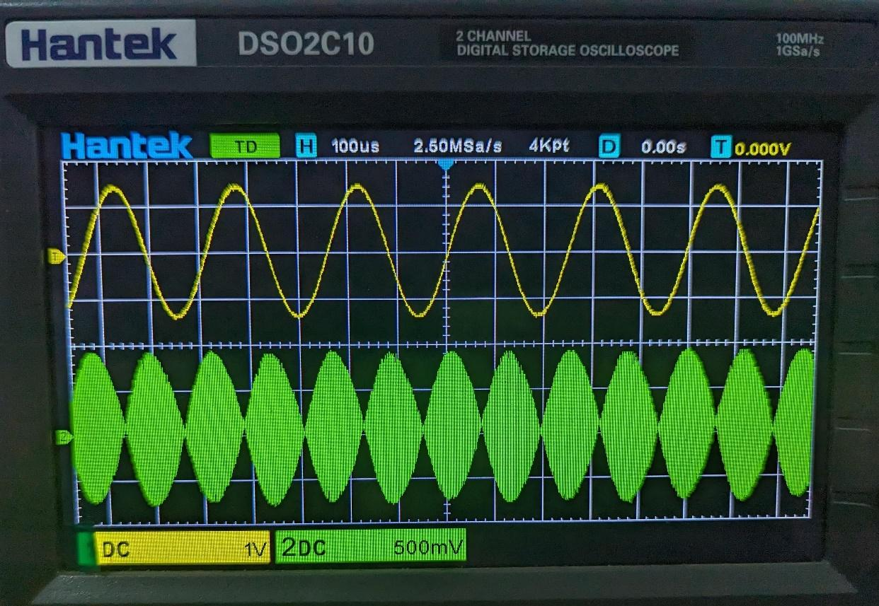

Fig 01: Modulated signal (yellow) and Demodulated signal (green)

**Experimental Data :**

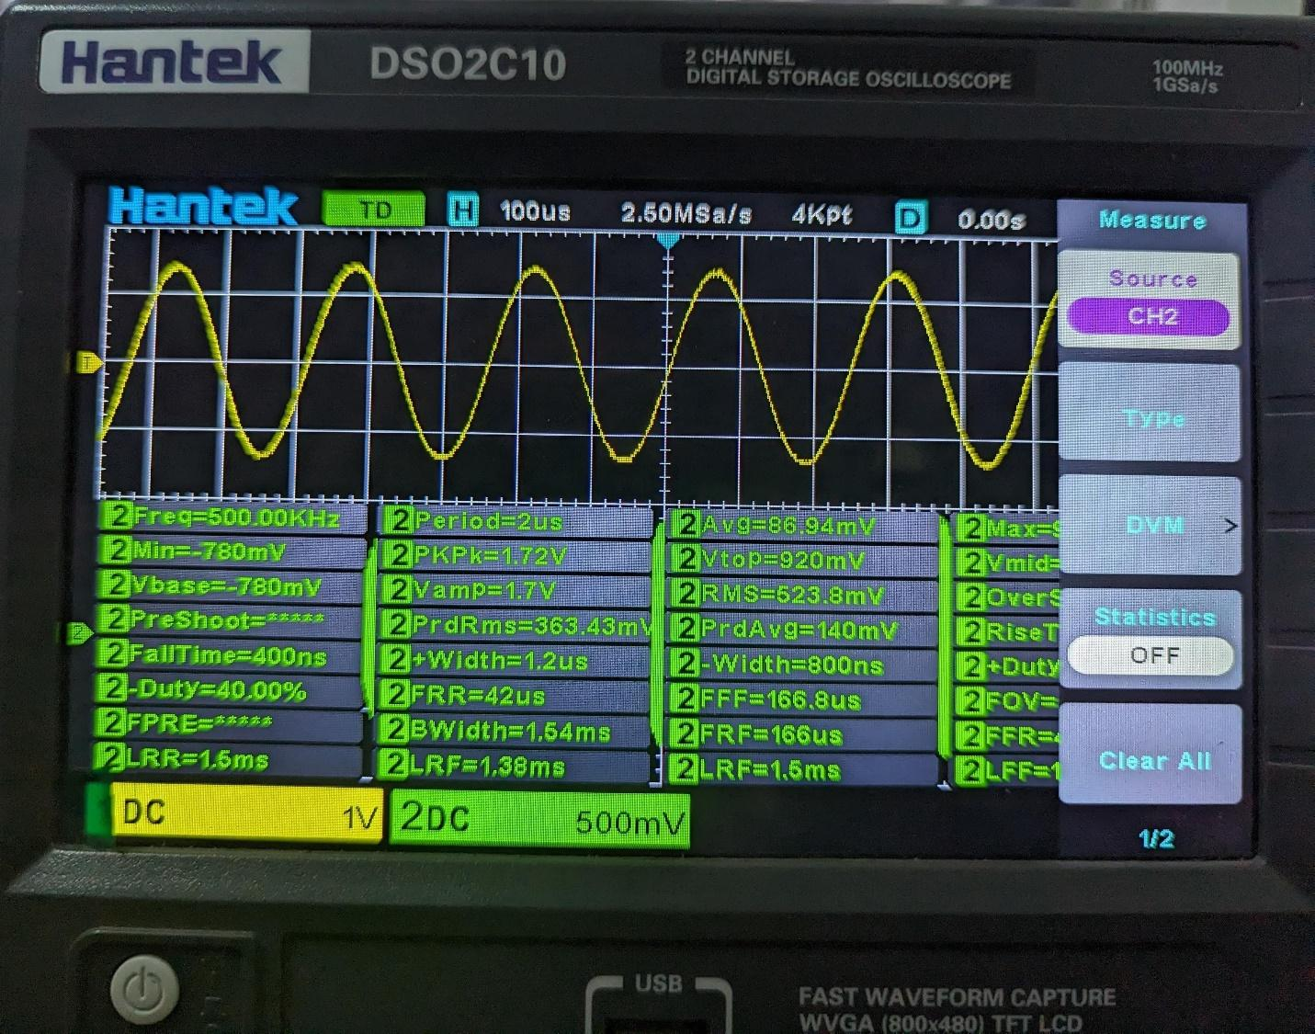

Fig 02:amplitude and frequency of the demodulated signal

**Questions & Answers :**

1. **Show mathematically how we can retrieve the message signal 𝑚(𝑡)*m*(*t*) from the modulated signal 𝑠(𝑡)*s*(*t*).**

To retrieve the message signal 𝑚(𝑡)*m*(*t*) from the modulated signal 𝑠(𝑡)*s*(*t*), we can use a product detector or demodulator. In the case of DSB-SC modulation, the product detector works by multiplying the modulated signal by the carrier signal and then passing it through a low-pass filter to remove the high-frequency components, leaving only the baseband signal.

Mathematically, the demodulation process can be represented as follows:

Given the DSB-SC modulated signal: 𝑠(𝑡)=𝐴𝑐𝑚(𝑡)cos⁡(2𝜋𝑓𝑐𝑡)*s*(*t*)=*Ac*​*m*(*t*)cos(2*πfc*​*t*)

Multiplying 𝑠(𝑡)*s*(*t*) by the carrier signal cos⁡(2𝜋𝑓𝑐𝑡)cos(2*πfc*​*t*): 𝑠(𝑡)⋅cos⁡(2𝜋𝑓𝑐𝑡)=𝐴𝑐𝑚(𝑡)cos⁡2(2𝜋𝑓𝑐𝑡)*s*(*t*)⋅cos(2*πfc*​*t*)=*Ac*​*m*(*t*)cos2(2*πfc*​*t*)

Using the trigonometric identity

cos⁡2(𝑥)=12(1+cos⁡(2𝑥))cos2(*x*)=21​(1+cos(2*x*)): 𝑠(𝑡)⋅cos⁡(2𝜋𝑓𝑐𝑡)=𝐴𝑐𝑚(𝑡)2(1+cos⁡(2⋅2𝜋𝑓𝑐𝑡))*s*(*t*)⋅cos(2*πfc*​*t*)=2*Ac*​*m*(*t*)​(1+cos(2⋅2*πfc*​*t*))

Passing the product through a low-pass filter to remove the high-frequency component, leaving only the baseband signal: 𝑚(𝑡)=LPF(𝑠(𝑡)⋅cos⁡(2𝜋𝑓𝑐𝑡))*m*(*t*)=LPF(*s*(*t*)⋅cos(2*πfc*​*t*))

Here, LPFLPF represents the low-pass filter operation.

1. **Draw the frequency spectrum of the Product Detector output.**

The frequency spectrum of the Product Detector output after demodulating a DSB-SC modulated signal consists of the original baseband signal centered around zero frequency.

Assuming the baseband signal has frequency components within a certain bandwidth 𝐵*B*, the frequency spectrum of the demodulated signal will have two copies of the original baseband spectrum shifted to positive and negative frequencies, each with a bandwidth of 𝐵*B*. This is because the demodulation process effectively translates the original baseband signal to higher and lower frequencies centered around the carrier frequency.

Therefore, the frequency spectrum of the demodulated signal will have two sidebands centered around the carrier frequency 𝑓𝑐*fc*​, each containing the frequency components of the original message signal, and separated by 2𝑓𝑐2*fc*​.

**Discussion:**

In our recent experiment, we explored a fascinating communication technique known as Double Sideband Suppressed Carrier AM (DSB-SC AM). Unlike conventional methods that transmit signals at a single frequency, we employed a strategy involving the simultaneous transmission of two frequencies— one higher and one lower. What sets DSB-SC AM apart is the deliberate omission of the central "carrier" frequency, resulting in notable power conservation. This innovative approach allows for more efficient utilization of resources, a crucial aspect in modern communication systems. Our experimental setup encompassed signal generation, manipulation using specialized equipment, and subsequent evaluation to gauge the integrity of the transmitted information. Through meticulous analysis, we gained valuable insights into the inner workings of DSB-SC AM and its potential applications in real-world communication scenarios. This experiment not only deepened our understanding of the underlying principles but also highlighted the promise of this method in optimizing communication systems for enhanced performance and efficiency.